 | JSPM’s  RAJARSHI SHAHU COLLEGE OF ENGINEERING  TATHAWADE, PUNE-33 | 
DEPARTMENT OF COMPUTER ENGINEERING

Mini Project
on
“ Diabetes Prediction System Using Machine Learning”

-Submitted by-
1. Madhura Chopade, Roll No: CS3131
2. Tanvi Gharge, Roll No: CS3133
3. Yash Gate, Roll No: CS3132

Class and Division: TY Div A
Course: Machine Learning
Academic Year 2025-26
(Semester-5)

- Title:
Diabetes Prediction System Using Machine Learning

- Abstract:
Diabetes is one of the most prevalent chronic diseases affecting millions globally, often leading to severe health complications if not detected early. This project presents a Machine Learning-based Diabetes Prediction System designed to identify the likelihood of a person having diabetes using clinical and physiological data. The system utilizes the Pima Indians Diabetes Dataset and applies multiple supervised learning algorithms, including Logistic Regression, Decision Tree, Random Forest, Support Vector Machine (SVM), and K-Nearest Neighbors (KNN). Data preprocessing techniques such as handling missing values and feature scaling were employed to ensure model reliability. After model evaluation using metrics like accuracy, precision, recall, F1-score, and ROC-AUC, the Random Forest Classifier demonstrated the highest performance with an accuracy of 80%, indicating its effectiveness in capturing complex patterns in medical data. The findings highlight the potential of machine learning in supporting healthcare professionals with early and accurate diabetes detection, thereby facilitating timely medical intervention. Future work involves integrating larger datasets and deploying the model as an interactive web or mobile application for real-time prediction.

- Background/ Introduction (about details of application)
Diabetes mellitus is a chronic metabolic disorder characterized by elevated blood glucose levels, which, over time, can lead to serious damage to the heart, kidneys, eyes, and nerves. According to the World Health Organization (WHO), the global prevalence of diabetes has been steadily increasing, making it one of the most significant health challenges of the 21st century. Early detection and proper management of diabetes are critical for reducing its complications and improving patients’ quality of life.
Traditional diagnostic methods rely heavily on manual medical tests and clinical evaluations, which can be time-consuming and may not always detect the disease in its early stages. With the rapid advancement of technology, Machine Learning (ML) has emerged as a powerful tool in healthcare analytics. ML techniques can analyze complex patterns in large datasets to make accurate predictions and support clinical decision-making.
This project leverages the power of machine learning to build an intelligent system capable of predicting whether an individual is likely to have diabetes based on key clinical attributes such as glucose level, blood pressure, body mass index (BMI), insulin level, and age. By using the Pima Indians Diabetes Dataset, the system applies various supervised learning algorithms — including Logistic Regression, Decision Tree, Random Forest, SVM, and KNN — to identify the model that provides the highest predictive accuracy.
The objective of this system is not only to assist in the early detection of diabetes but also to provide healthcare practitioners with valuable insights into the key factors influencing the disease. The proposed approach demonstrates how data-driven models can enhance medical diagnosis and contribute to preventive healthcare strategies.

- Problem Statement:
Diabetes is a major global health issue that can lead to serious complications if not detected early. Traditional diagnostic methods are often time-consuming and may fail to identify potential cases in their early stages. With the availability of large healthcare datasets, there is a need for an intelligent system that can automatically predict diabetes based on clinical data.
The main problem addressed in this project is:
To develop a machine learning-based model that can accurately predict whether a person is diabetic or non-diabetic using key health attributes.
This system aims to support early diagnosis and assist healthcare professionals in timely intervention.

- Objectives:
The main objectives of this project are:
- To develop a predictive model for detecting diabetes using supervised machine learning algorithms.
- To compare the performance of different classifiers such as Logistic Regression, Decision Tree, Random Forest, SVM, and KNN.
- To identify the most influential features contributing to diabetes prediction.
- To assist healthcare professionals in early diagnosis and preventive decision-making through data-driven insights.
- To provide a foundation for deploying the model as a real-time predictive system in healthcare applications.

- Libraries required:
The following Python libraries were used to implement the Diabetes Prediction System:
- pandas – For loading, cleaning, and manipulating the dataset.
- numpy – For performing numerical and mathematical computations.
- matplotlib – For creating static plots and visualizations.
- seaborn – For advanced data visualization and correlation analysis.
- scikit-learn (sklearn) – For implementing machine learning models, preprocessing, model evaluation, and performance metrics.

- Approach/ Methodology:
The development of the Diabetes Prediction System followed a systematic machine learning workflow consisting of several key stages:
- Data Collection
  - The dataset used for this project is the Pima Indians Diabetes Dataset, which contains medical and physiological data of female patients.
  - It includes eight clinical features and one target variable indicating whether the patient is diabetic (1) or non-diabetic (0).
- Data Preprocessing
  - Replaced invalid zero values in columns like Glucose, BloodPressure, BMI, SkinThickness, and Insulin with median values.
  - Standardized all feature values using StandardScaler to ensure uniform data distribution and improve model performance.
  - Split the dataset into 70% training and 30% testing sets for model development and evaluation.
- Exploratory Data Analysis (EDA)
  - Conducted visualization using Matplotlib and Seaborn to understand feature distributions and correlations.
  - Created heatmaps, boxplots, and histograms to identify patterns and relationships among features and diabetes outcomes.
- Model Building
  - Implemented multiple supervised learning algorithms including:
    - Logistic Regression
    - Decision Tree
    - Random Forest
    - Support Vector Machine (SVM)
    - K-Nearest Neighbors (KNN)
  - Each model was trained on the preprocessed data and tested using unseen data.
- Model Evaluation
  - Evaluated models based on Accuracy, Precision, Recall, F1-Score, and ROC-AUC metrics.
  - Performed 5-fold Cross-Validation to ensure model reliability and reduce overfitting.
  - The Random Forest Classifier achieved the highest accuracy of 80%, making it the best-performing model.
- Feature Importance Analysis
  - Used the Random Forest model to identify significant predictors such as Glucose, BMI, Age, and DiabetesPedigreeFunction.
  - Insights were drawn to understand which features most influence the prediction outcome.
- Visualization and Interpretation
  - Plotted confusion matrix and ROC curve for the best-performing model to visualize classification performance.
  - Interpreted results to provide actionable insights for early diabetes detection.

- Implementation
Git-Hub Link:

- Results:
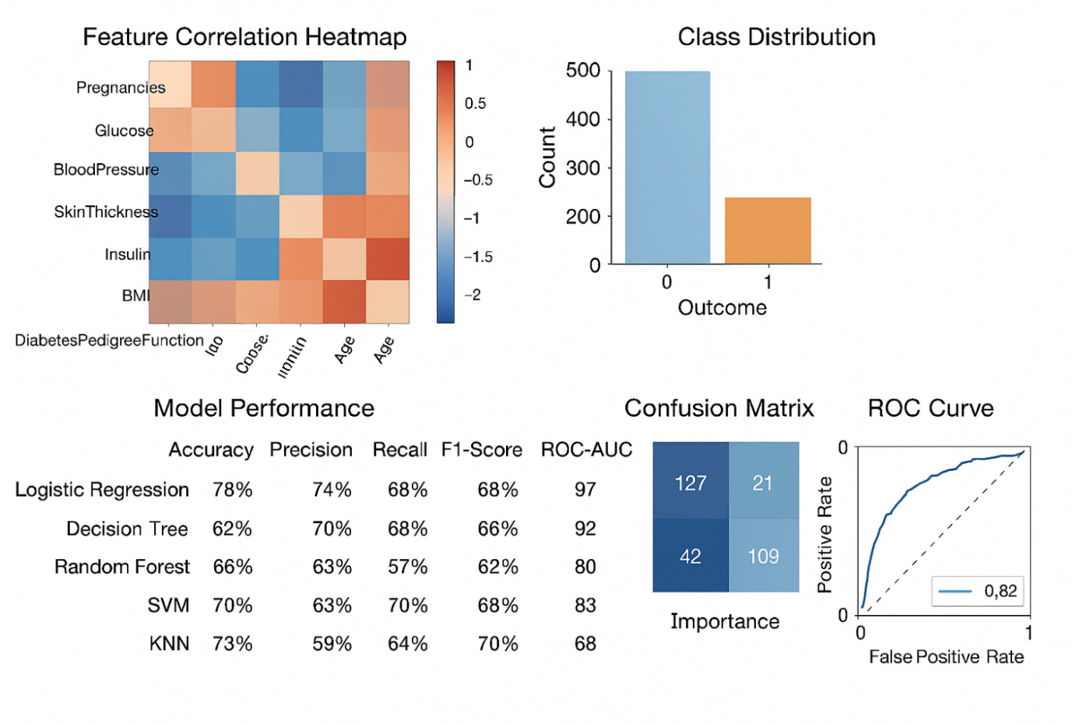

- Conclusion:

- Machine Learning can effectively predict diabetes with good accuracy.
- Ensemble methods like Random Forest outperform simple models.
- Early prediction allows healthcare professionals to take preventive measures

